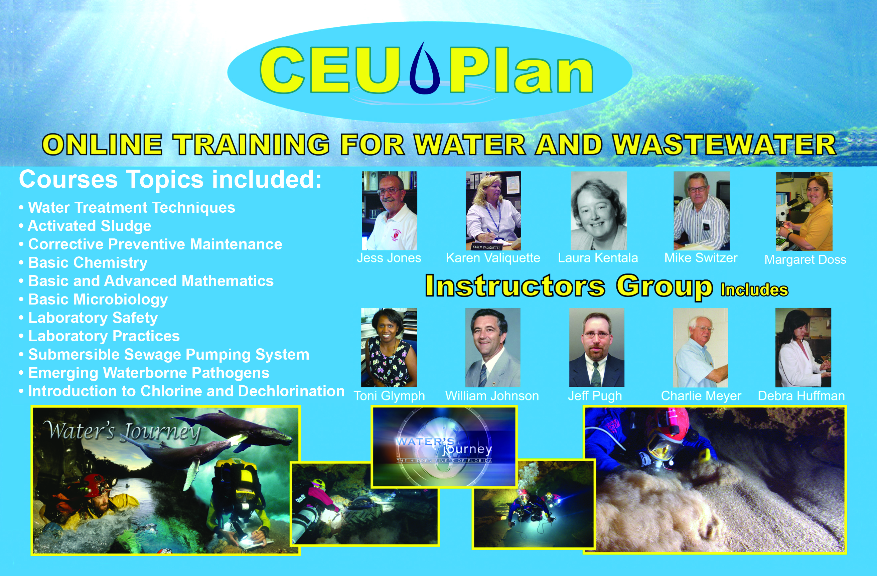

Instructor Group
The Instructor Group is a unique group of subject matter experts (SMEs) in the water and wastewater treatment field who have prepared all of our online courses. Our home page and course outlines exemplify their experience and knowledge pertaining to the topics and courses. CEU Plan has leading researchers, academics, retired operators and managers, and professionals within the fields of drinking water and wastewater, engineering, and related regulatory agencies, who provide quality assurance throughout the course curriculum. The Instructor Group is comprised of leading SME experts in the water and wastewater field with a combined experience in excess of 1,750 years. This Instructor Group is a unique feature of our program.

Links to some instructors:

Russ Martin's video promoting "Wastewater Treatment Clarifier Performance"
http://3300965418614cc8467e-f142db06859bbb4db0fc3355c598d4e2.r90.cf2.rackcdn
.com/250_Trailer.wmv
Toni Glymph-Martin's video promoting "Wastewater Microbiology And
Process Control"
http://3300965418614cc8467e-f142db06859bbb4db0fc3355c598d4e2.r90.cf2.rackcdn
.com/143_Trailer.wmv
James Holeva's video about "Backflow Prevention" Devices
http://3300965418614cc8467e-f142db06859bbb4db0fc3355c598d4e2.r90.cf2.rackcdn
.com/HolevaIntro_MQ.wmv
Margaret Doss' video about "Laboratory Practices" courses
http://3300965418614cc8467e-f142db06859bbb4db0fc3355c598d4e2.r90.cf2.rackcdn
.com/MargaretDoss-InstructorVideo.wmv

To view our complete Instructor Group: https://www.ceuplan.com/InstructorProfiles.aspx

